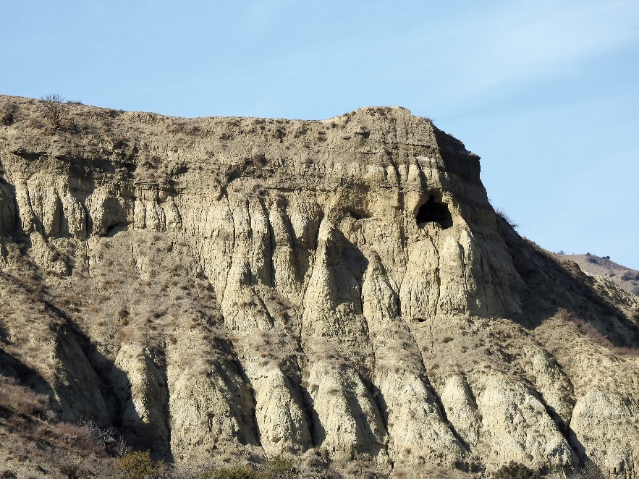
Nikoloz Zhgenti - Historic Monuments of Satorge and Kajiri Mountains: New Materials about The Peripheral Monasteries of Gareji and other Monuments of Historic Kambechovani (Tbilisi, 2025)
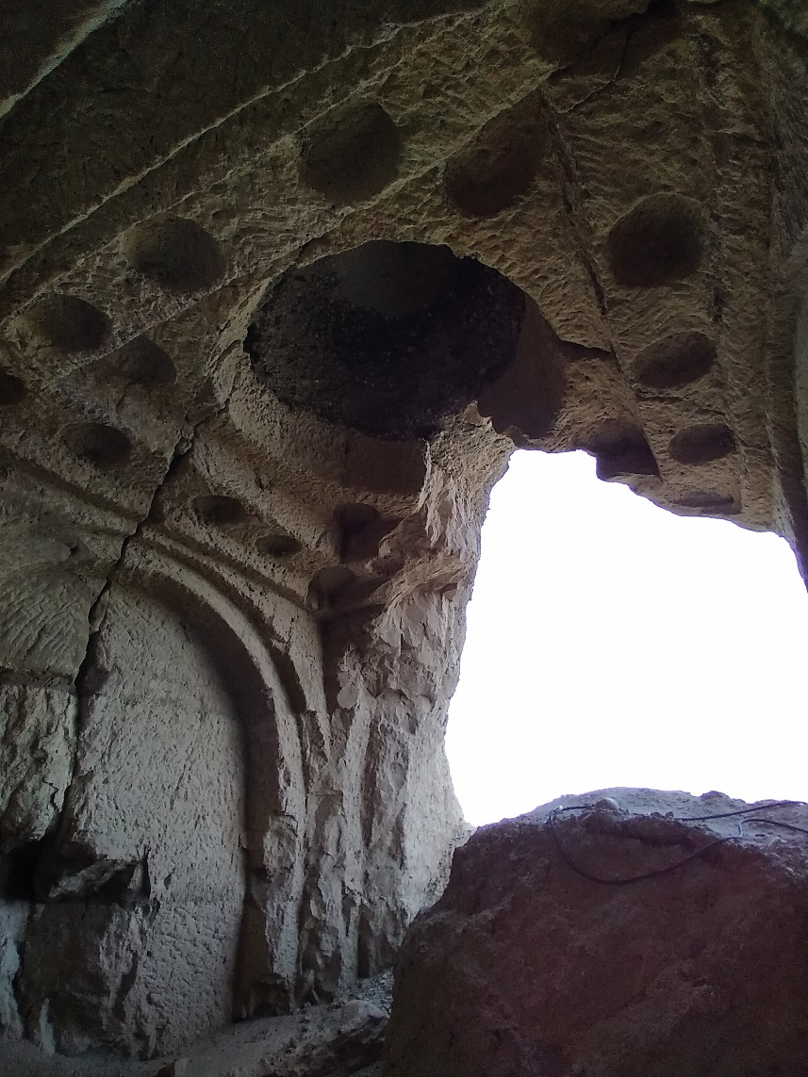
It is a pleasure to draw attention to a new book published by the Centre of Georgian Cultural Heritage Preservation and Research with the support of a FaRiG John Wilkinson Research Grant. The Centre exists to study and record monuments of the Georgian cultural heritage, and this volume (their first) is devoted to the lesser-known monuments of the Satorge and Kajiri Mountains area in Kakheti (on the lower valley of Iori river), near the southern border of the municipalities of Sighnaghi and Dedoplistskaro. The cave monasteries belong to the fringe of the David Gareji monastic complex and are in most cases inaccessible without mountaineering equipment. The intrepid members of the Centre have made nearly a dozen visits over the past five years, recording inter alia a large settlement near Satorge monastery dating to the 9th to 14th centuries now reduced to widely scattered domestic ceramics and glassware, as well as three small monastic complexes. The latter included a rock-cut domed church. Many inscriptions and graffiti were recorded. One church contained numerous inscribed tamgas that are tentatively attributed to Mongol Golden Horde invaders
The author is quite explicit in the purpose of this publication: it is to make the monuments at Satorge and Kajiri known to wider audiences, in the first place to the scientific community, but also to the public at large. With this in view, Nikoloz Zhgenti has placed Historic Monuments of Satorge and Kajiri Mountains on line (Google Zhgenti + Satorge + Kajiri, choose the National Library of Georgia website, and download the file SatorgesaDaYajirisMtebisIstoriuliDzeglebi.pdf at the bottom of the page). The bilingual publication has numerous excellent colour pictures: a judicious selection of the 200+ slides that were shown at the book’s recent presentation in Tbilisi.

Michael Vickers

Professor Michael Vickers
Jesus College
Oxford OX1 3DW

